**5 DAYS SAFARIS FOR MOUTAIN GORILLAS**

**The endangered Mountain Gorillas are the largest primates on planet can way up to 500pounds, the heaviest Silverback (male Gorilla) recorded weight is 585 ibs.They share 98% DNA with humans and can contract cold, flu or any other sickness from humans, that’s why the Uganda Wildlife Authority controls number of visitors to see Gorillas in National Park. Gorillas in Uganda can only be seen in Bwindi Impenetrable and Mgahinga Gorilla National Parks and former being the best.**

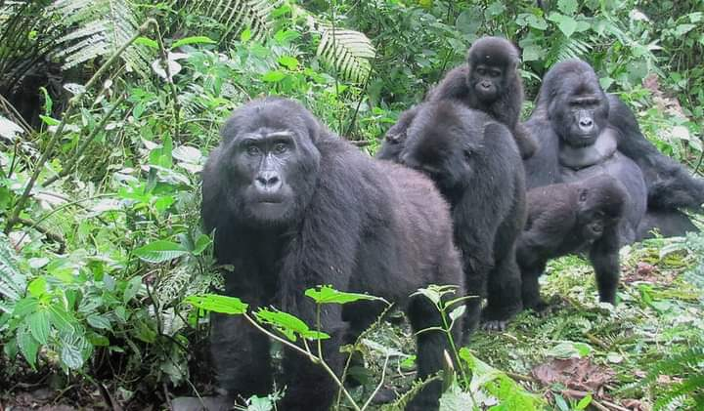

**Itinerary**

**Day 1: Arrive in Entebbe International Airport**

Meet and greet our guide (FRIENDS NATURES SAFARIS) at the airport then transfer to hotel

* Acacia Lodge in kampala

**Day 2: Bwindi Impenetrable National Park**

After breakfast we depart for our journey from the capital to southern part of the country with a stopover at the Ugandan Equator for Experiment and taking snaps, while our guide is serving us a cup of coffee or tea, having lunch en-route at Igongo Cultural Centre ,we continue passing through the beautiful landscapes known as the ‘’Switzerland of Africa’’: mountains, lakes, hills with cultivated terraces, tropical rain forest and bamboo forest and finely we arrive at the Lodge check-in for dinner and overnight stay, evening at leisure.

* Driving time: ± 11 hours

Accommodation:

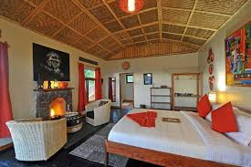

[**Day 3: Gorilla Tracking (3-8 hours)**](http://www.friendsnaturesafaris.net)

After breakfast we arrange in our groups at the briefing point, accompanied with a ranger guide we start tracking Gorillas as we can move along distance in rainy, muddy and sloppily areas without seeing any Gorilla, carry with you drinks and a light snack served by our guide as you as you can take a while without seeing Gorillas once you see them, spend with them only one hour for conservation purposes to find them the ranger guide will lead you where the we sighted previously, you can take photos as you watch them playing and feeding young ones with a camera no flash. After our trek and humbled by this incredible experience, return to the road where our driver-guide will be waiting for us. Transfer back to the lodge for a late lunch. Rest of the day is at leisure**.**

* Budget Tour: Buhoma community badas.
* Luxury Tour: Silverback Lodge,Buhoma Lodge.

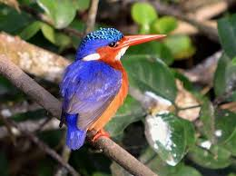

**Day 4: To Kampala**

In the morning after relaxed breakfast you will travel back to Kampala. On the way back to the city you will have lunch on the way, stop at the craft shops to soveignirs and in evening we enjoy Kampala by Night Tour

* Driving time: ± 10 hour
* Accacia Lodge in Kampala

**Day 5: To Kampala**

Depending on time of your flight transfer to airport, if it’s in the evening we can pass via UWEC for a brief tour of Ugandan Birds, Animals, Plants and other primates like Chimpanzees, Baboons and Monkeys.